**How to run:**

* Install node.js
* Install npm modules using command: npm install
* Open cypress UI runner: npx cypress open
* Easiest way to run tests through Cypress UI runner[See the screenshots]

**Other information:**

* Find page path here: cypress\support\page_objects\AnzMuchBorrow.js
* Find spec file having test here: cypress\integration\DemoTests\anzSpecOne.js

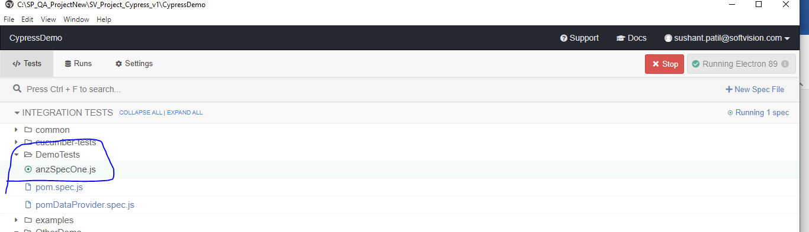

Evidence:

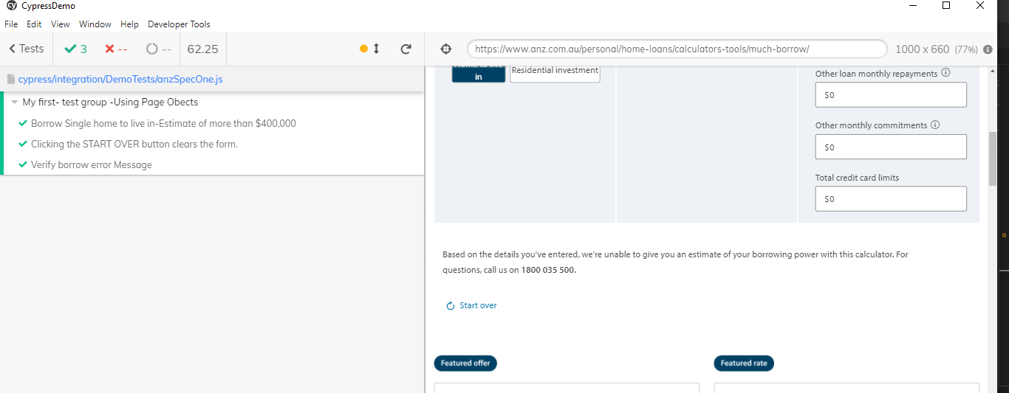

Test case 1: Borrow Single home to live in-Estimate of more than $400,000

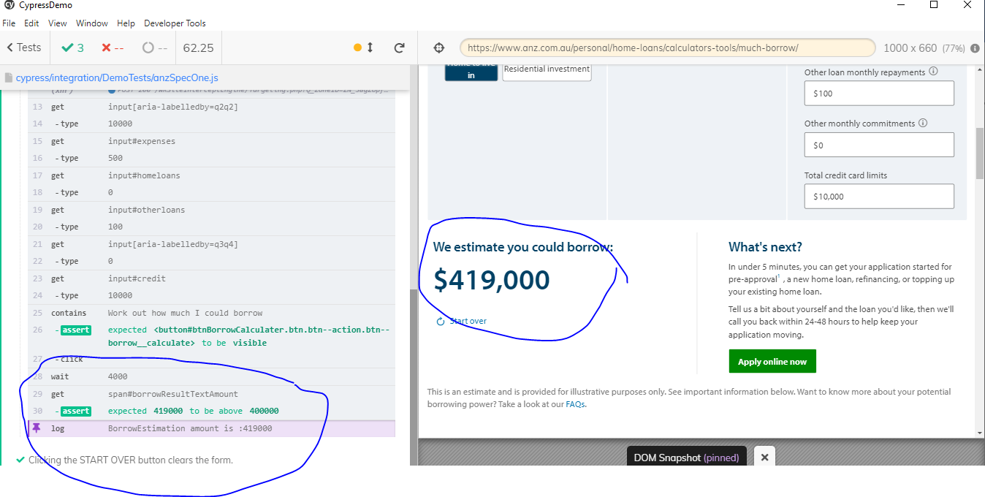

Test Case 2: Clicking the START OVER button clears the form.

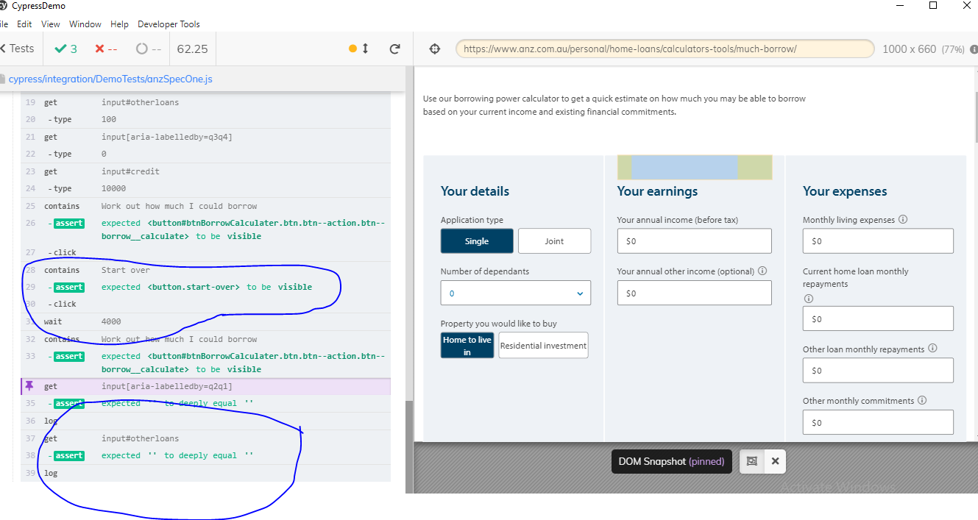

Test case 3: Verify borrow error Message

